NAME___________________ DATE_______ PERIOD____
European Landmark Project
DUE: _____________

Pretend you are an engineer/artist who has been approached by a client requesting a one-of-a-kind collage displaying 8 to 10 of Europe’s most notable landmarks. Your client is willing to pay all expenses and materials associated with this project as well as $150,000.00 for the completed project. Your client has made it clear the artwork must be hand-crafted, to display on the wall (canvas, poster, cloth, frame or shadow box), and cannot be larger than 8 ½ x 11. You decide a trip to Europe is necessary to truly get a feel for the landmarks in person. You plan to visit as many European landmarks as possible to assist you with selecting the landmarks to be used for the project.

Ok, so what are you supposed to do?

For your project, you need to prepare brief proposal outlining airfare and hotel expenses for a 12-day trip to Europe (see proposal template on back). To accomplish this, you must decide on which landmarks and cities to visit within 12 days. Traveling by car or train, you will visit at least 4 of the 5 sub-regions. You will also need to have at least 1 major landmark from each region you visit. When visiting a foreign country, it is important to know the language and currency rate of the location you are visiting, so you will include this information as well. Also, you must be familiar with the climate so that you know what kinds of clothes to pack according to the places you plan to visit! You will also need to provide a map charting your journey (either printed or drawn) to the cities of each landmark you plan to visit. The proposal template must be complete and your map stapled to this page. Submit this with your art project.

What do you need to turn in?

This instruction page (complete template on back) and a map of your travel itinerary. This project will display a collage of 8-10 landmarks. The landmarks will be recreated by hand and presented in a way that is visually appealing. A successful project will not only depict each landmark’s unique characteristics, it will also demonstrate purposeful design and layout. This project has to be able to display on the wall and cannot be bigger than 8 ½ x 11.

This is an example of a landmark collage
(your work must be original)

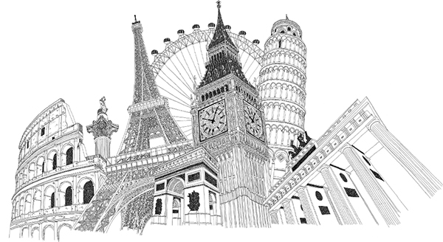
 | Travel Info  (Flight, train, rental car/boat etc.) | Hotel Info | Landmark /  City / Country | Language(s) | Climate (season) | Currency
Travel begins  Day #1:  (day/month) | Depart.Airport/city  Arrival.Airport/city  Airline  Airfare $ | Hotel Name  Nightly Rate $
Day #2:
(day/month)
Day #3:
(day/month)
Day #4:
(day/month)
Day #5:
(day/month)
Day #6:
(day/month)
Day #7:
(day/month)
Day #8:
(day/month)
Day #9:
(day/month)
Day #10:
(day/month)
Day #11:
(day/month)
Travel return  Day #12:  (day/month) | Depart.Airport/city  Arrival.Airport/city  Airline  Airfare $
Expense Total(s)
European Landmark Project Expense Proposal Template

